**Malnutrition - causes and types**

Malnutrition especially that affecting young children is one of the principle public health problems in the developing world like India. It causes about half of child deaths and is a major cause of morbidity in children. It has medical and social disorder rooted in poverty and discrimination. It has economic ripple effect that hampers development

Effects of malnutrition in early childhood can be devastating and permanent. Whether or not children are well-nourished during the prenatal period and the first years of life can have a profound effect on their health status, as well as their ability to learn, communicate, socialize, reasoning and adapt to their environment

**Ecology of under nutrition**

Malnutrition is an ecological problem that does not occur alone. It accompanies poverty, disturbed family structure, ignorance and despair.

**Poverty**

Because of low purchasing power, poor cannot afford to buy desired amount and desired quality of food for the family. This adversely affects their capacity for physical work and they earn less. Thus starts a vicious cycle of poverty, under nutrition, diminished work capacity, low earning and poverty

**Feeding habits**

Lack of awareness of nutritional qualities of food, irrational beliefs about food, inappropriate child rearing and feeding habits all lead to under nutrition in the family.

**Infections**

Infections like malaria and measles or recurrent attacks of diarrhoea may precipitate acute malnutrition and aggravate the existing nutritional deficit. Metabolic demands for protein are higher during infections and the child may take in less food either due to reduced appetite or due to food restrictions by the mother. Thus leading to malnutrition

**Socio-cultural factors**

* Inequitable distribution of food in the family. In most of the poor households, women and preschool children especially girls receive less food than the economically active male members
* Large families Rapid succession of pregnancies adversely affects the nutritional status of the mother. As she tries to manage the big family she may neglect her own health and antenatal checkups during pregnancy. Under nutrition may lead to low birth weight baby. In large families per capita availability of food is also less.
* Poor quality of housing, sanitation and water supply. These contribute to ill health and infections thus Contributing to malnutrition.
* Inadequate maternal and child care- Improving the primary health centres and other health care services in the rural areas will definitely improve the nutrition profile of women and children.

**Causes of child malnutrition can be summarised as below.**

• 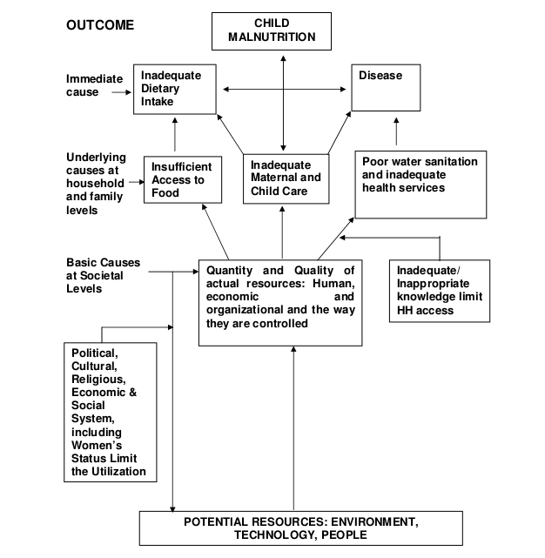

**Groups of population most affected**

Certain groups of population may be most affected because of their,

* Biological vulnerability as in infants, preschool children, pregnant mothers,adolescent girls and old people.
* Socioeconomic factors like poor, socially deprived, slum dwellers, street kids, etc.
* Habitat such as those living in inaccessible remote areas, thick forests and mountainous regions e.g., tribal population and nomads.